**Sequence Diagram**

1. **Sequence diagram for transfer money**

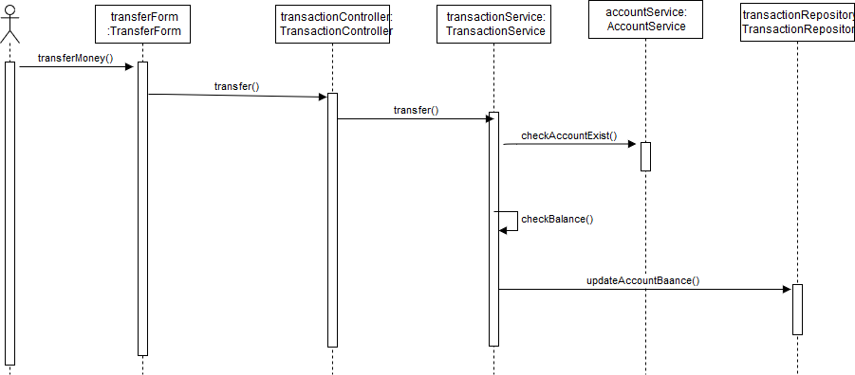

1. **Sequence diagram for withdraw**

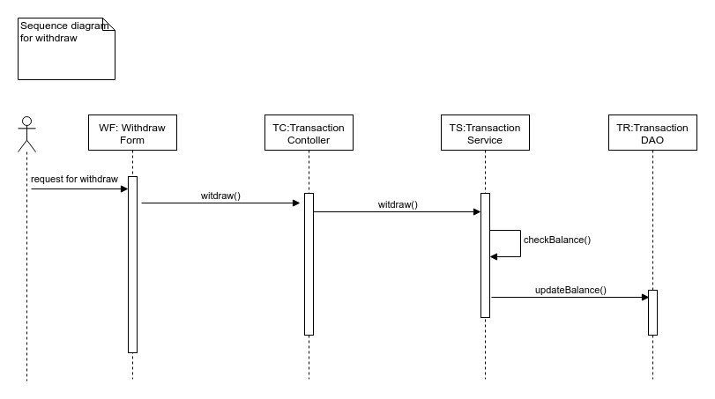

1. **Sequence diagram for Create account**

